Final project TIC

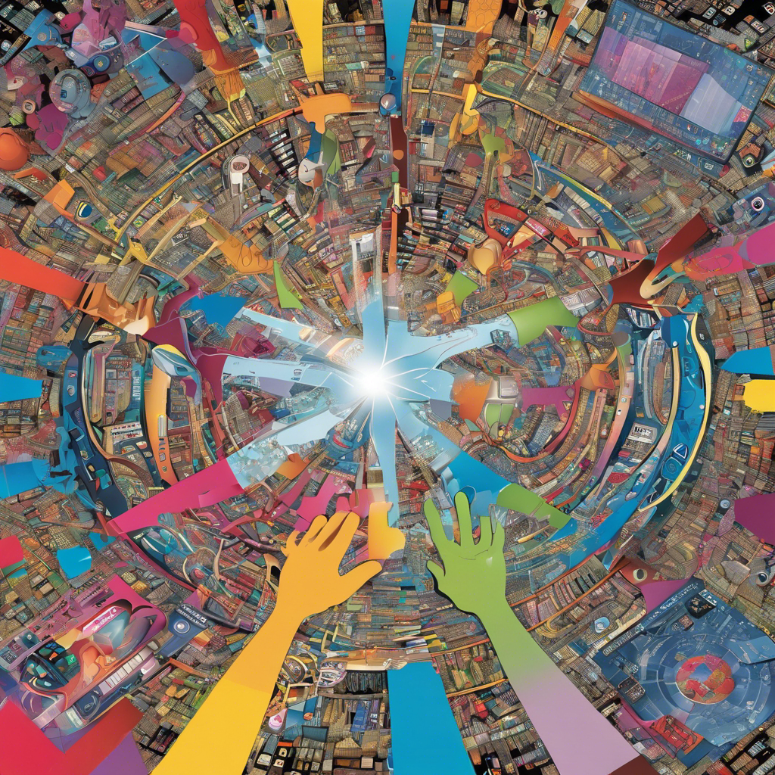

***REPORT ON INFORMATION AND COMMUNICATION TECHNOLOGIES .. TECHNOLOGIES RELATED TO TIC.***

CONTENT

|  |  |
| --- | --- |
| Page | content |
| *03* | ***Introduction*** |
| *04* | ***Definition of TIC*** |
| *05* | ***Technologies*** |
| *06* | ***ICT issues and economic importance*** |
| *07* | ***Convergence of technologies*** |
| *08* | ***Areas of applications of TIC*** |
| *09* | ***Communication tools*** |
| *10* | ***Benefits of investing in ICT*** |
| *11* | ***Limits of investment in ICT*** |
| *11* | ***Technologies related to TIC*** |

***The history of Information and Communication Technologies (ICT) is a fascinating journey marked by transformative advancements in communication, computing, and connectivity. The roots of ICT can be traced back to the 19th century with the invention of the telegraph, which laid the groundwork for long-distance communication. The subsequent development of the telephone, radio, and television in the early to mid-20th century marked significant milestones in mass communication and broadcasting. The emergence of electronic computers…***

**1/ Introduction**

ICT, information and communication technologies, brings together all the tools, software or hardware for processing and transmitting information: digital cameras, televisions, mobile phones, computers, etc. Generally speaking, all means of electronic communication are targeted, whatever their form (written, pictorial, spoken, etc.) and their target (customers, suppliers, company, relationships, etc.). - ICT are tools generated by progress in computing and telecommunications technology “TELEMATICS”. ICT is present in 3 main categories: - telecommunications including call centers, mobile telephony, GPS system, etc. - electronics, components, consumer equipment, televisions, DVD players, etc. - Internet, servers, networks, advice, troubleshooting...

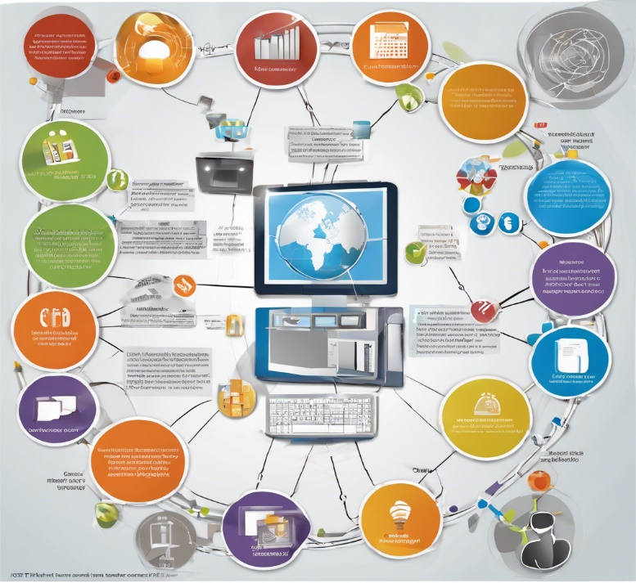

**02/ Definition of TIC :**

The expression “Information and communication technologies” transcribes an English expression used in various international bodies which roughly corresponds to the field of telematics. It has different definitions depending on the point of view of the authors or depending on the era, due to the progressive blurring of the boundaries of the fields concerned and the rapid evolution of techniques with digital convergence.

The definition of ICT remains particularly vague: the term “technology”, which means “discourse on technology”, is used instead of “technical”, which would be both simpler and more exact. Information and communication technologies are tools supporting information processing and communication, information processing and information communication remaining the objective, and technology, the means .

Information and communication technologies (ICT) represent all the meansor equipment (hardware and software or programs) ensuring the automatic processing of nformation The term automatic information processing designates:

a- Calculation (arithmetic i.e. using the arithmetic operators: +,-, /,* and the calculation logic for propositions i.e. using the logical operators: AND, OR, IF, NOT...)

b- Data management and recording.

c- Communication and exchange of data: the transmission and reception part of information.

- The term hardware and software equipment refers to the physical part or components electronic, this part is controlled by a software part (set of programs or instructions) which is used for the management and control of the hardware part, for example the system operating system Windows XP Professional is a set of programs ensuring the management or controlling the computer hardware part

**3/ Technologies**

ICT brings together a set of resources necessary to manipulate information and particularly the computers, programs and networks necessary to convert it store, manage it, transmit it and find it.

ICT can be grouped by the following sectors :

* IT equipment, servers, IT hardware (PC, printer, switch, etc.);
* Microelectronics and components (transistor, diode, integrated circuit, etc.);
* Telecommunications and computer networks;
* Multimedia;
* IT services and software

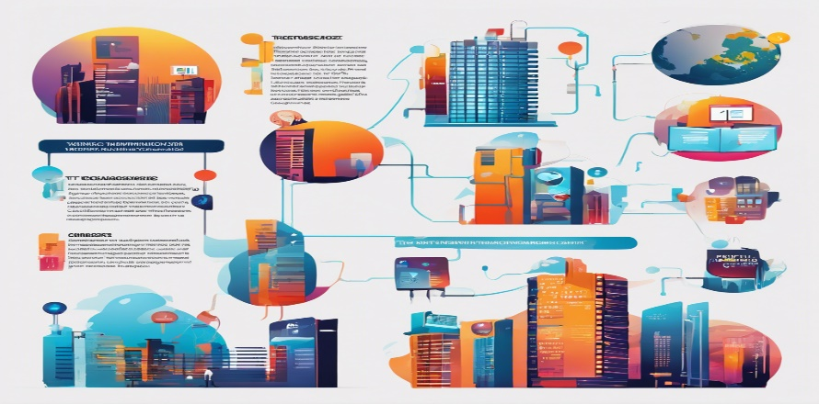

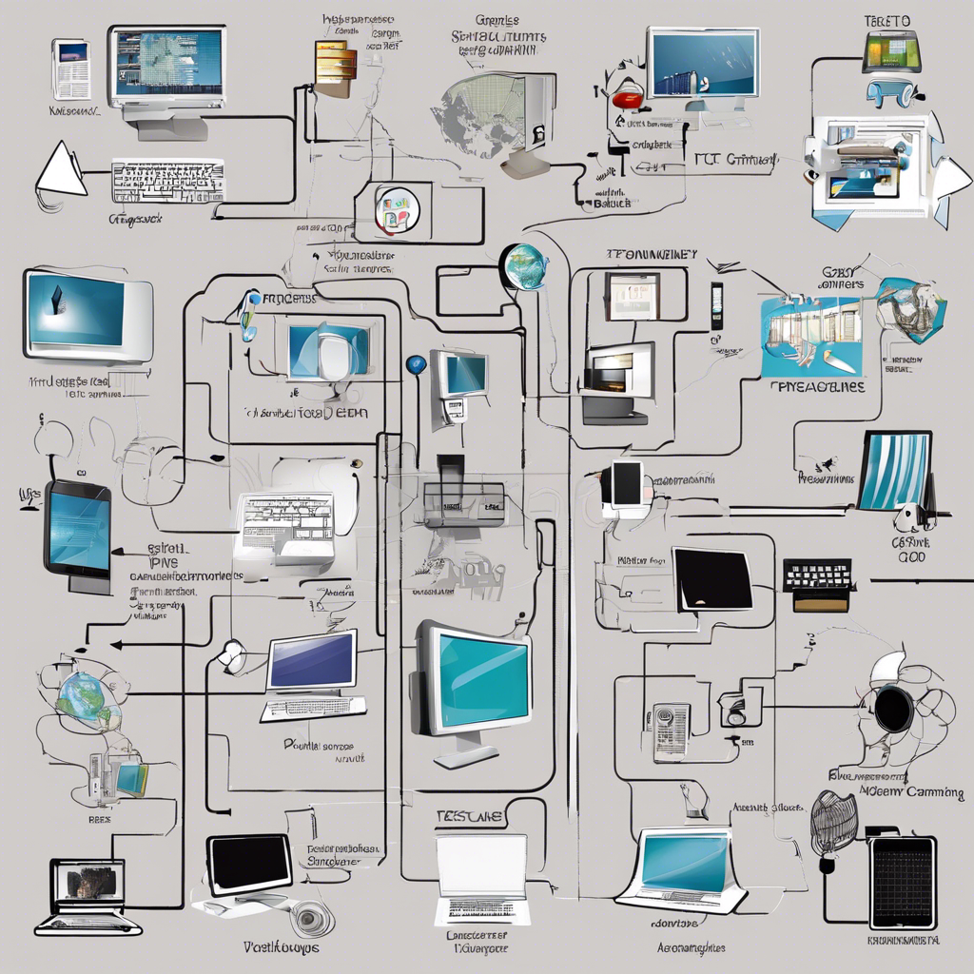

**4/ICT issues and economic importance**

ICT plays a major role in the competitiveness of businesses and in the efficiency of administrations and public services (health, education, security). They have also become crucial for the production and dissemination of cultural goods. According to the Key Technologies 2015 report, “the information and communication technologies (ICT) sector has become a major segment of the economy of the main industrialized countries with a direct contribution of 5.9% of GDP in Europe ( and 7.5% in the United States). Beyond the sector itself,

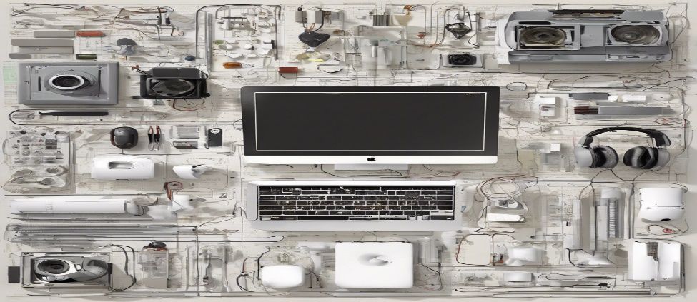

ICT contributes to the development of all other economic sectors, with ICT representing more than 50% of productivity growth in Europe (source: European Commission)”22. The growth prospects for the ICT (Information and Communication Sciences and Technologies) sector are also considerable, representing +8% growth per year for the Internet economy between 2013

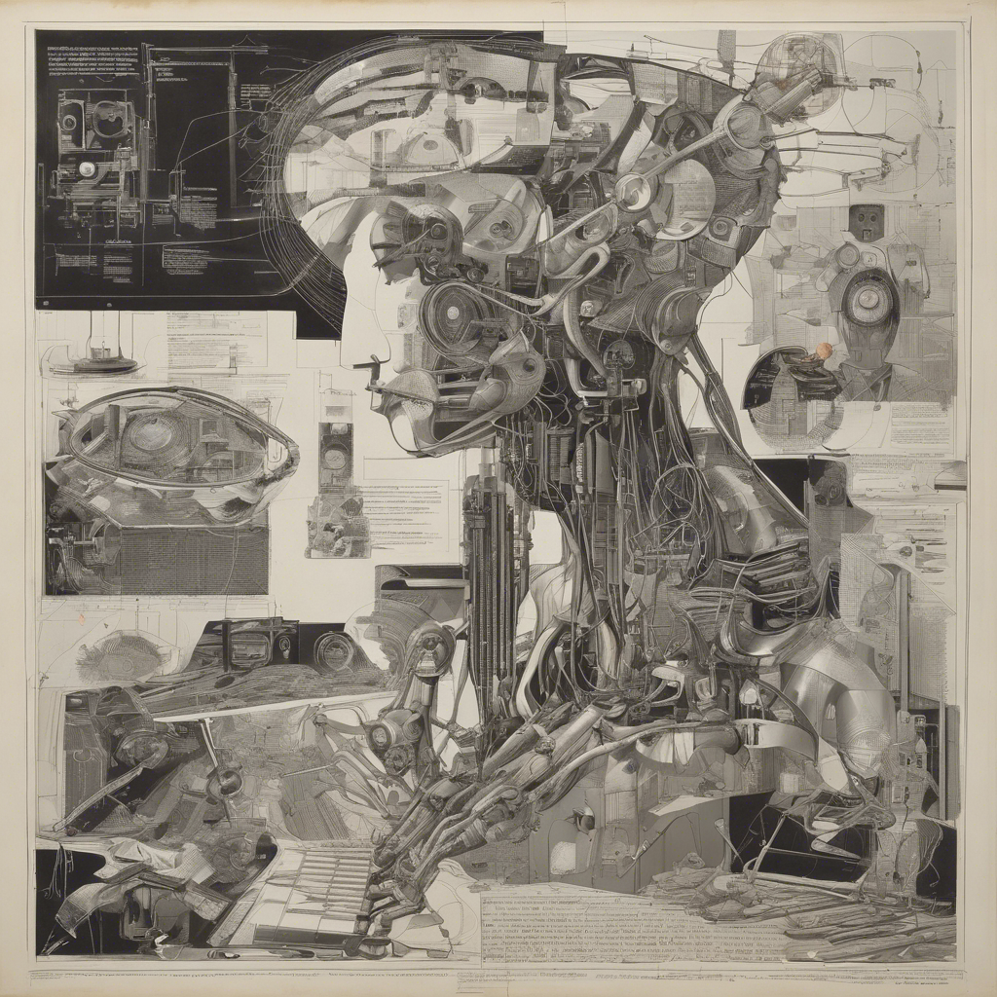

**5/ The convergence of technologies**

Communication technologies include the techniques, tools and methods used to facilitate communications. Information technology includes techniques, tools and methods used to create, save, modify and display the communicated content.

These two types of technologies were developed separately until the 1970s, when information technology began to be applied to the telecommunications network. The term “information and communication technologies” (ICT) has been adopted to reflect the convergence of these two types of technologies and associated industries.

The birth of ICT is due in particular to the convergence of computing, telecommunications and audiovisual .

These are some examples :

|  |  |
| --- | --- |
| **Exemple 01** | the computer that offers voice in addition to text and graphics,  cell phones that allow you to receive text and graphics in addition to voice. |
| **Exemple 02** | a personal computer was mainly used for word processing and calculations with a spreadsheet. Then in the 90s, it was also used for email and slide presentations. A computer was therefore clearly computing equipment. But with digital convergence, a personal computer is becoming a basic tool for the audiovisual and multimedia field. He can be :  ➢ A telephone terminal with Voice over IP service.  ➢ A videocommunication terminal (Skype, Messenger.)  ➢ A television screen to receive broadcasts online or in catch-up mode.  ➢ A screen to view photos or videos from user-generated service platforms (Instagram, Youtube, etc.).  ➢ A tool for editing films from a set of videos taken with your camcorder or smartphone. |

**6/ Areas of application of ICT**

ICT plays a major role in the competitiveness of businesses and in the efficiency of administrations and public services (health, education, security). ICTs have also become a crucial issue for the production and dissemination of cultural goods.

These technologies present themselves as a necessity in the context of society in which rapid changes, increasing knowledge and demands for constantly updated high-level education are transformed into a permanent requirement. This concerns almost all areas of our company, the main areas of application of which are:

1. Administration and governance ;
2. Education ;
3. Training ;
4. Health;
5. Commerce: Websites can be used to make online purchases;
6. Geolocation;
7. Transport: Electronic ticketing and online reservation

**7/ Communication Tools**

**1. Delayed (or asynchronous) exchanges:** not requiring the interlocutors to be available at the same time

* ***Email*** makes it very easy to communicate with one or more people. An email is intended to transmit written information that may contain attached files (images, videos, etc.).
* ***Social media and networks:***social media and networks such as Twitter or Facebook make it possible to exchange information with a community of people. For some of them, there is a public part as well as a private part where the information published may be different.
* ***Forums***allow people to exchange information in the form of questions answers. This tool makes it possible to develop a knowledge base by theme that is very useful for a community sharing the same needs.

In addition to web tools, we also find:

* ***SMS:***these are small messages that can be sent to mobile phones. Their main advantage is that they allow information to be exchanged quickly from any location.
* ***Fax:*** very well known, the fax still remains a widely used means of sending important administrative documents.

**2. Instantaneous (or synchronous) exchanges:** the interlocutors are available at the same time

***The telephone:*** originally transported on completely separate network infrastructures (switched telephone network, ISDN, etc.), the telephone is gradually integrated into computer networks and the border between voice over IP, practiced from a computer with tools such as Skype, and traditional telephony tend to gradually disappear.

***Instant messaging****:* also known as “chat”, it allows written dialogue between one or more people. The dialogue is interactive. These systems (IRC, MSN, Skype, etc.) work on a computer but also on the latest generation telephones. Some applications also allow you to talk or see each other. Audioconferencing: this technology allows you to communicate orally with one or more people. It is simple to use and has the advantage of operating without too many technical constraints. You can have an audio conference both by telephone and by computer.

***Videoconferencing:*** this device allows you to communicate visually with one or more interlocutors. It is very practical for communicating with people who are geographically distant. More resource-intensive than audioconferencing, it requires a higher bandwidth and therefore a better internet connection or an expensive dedicated link.

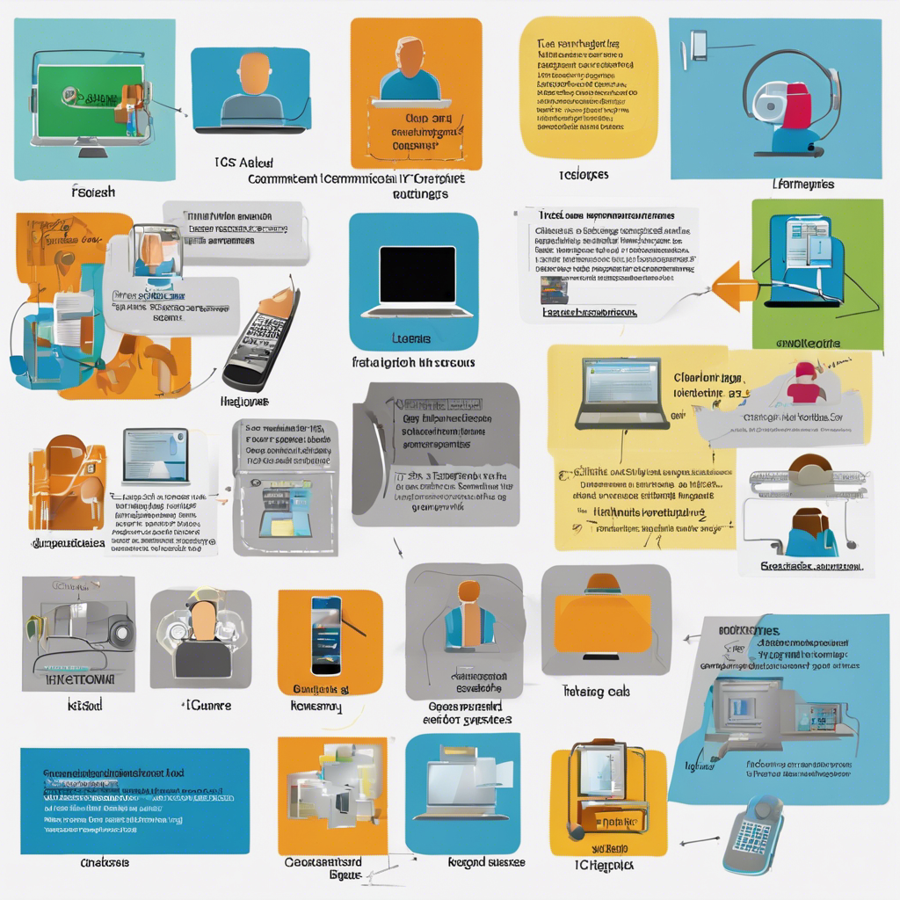

**8/ Benefits of investing in ICT**

1- It simplifies everyday life. Almost all popular technologies ranging from the telephone to the car have the ultimate objective of reducing human effort.

2- A second advantage is communication and mobility. The systems of modern communications have radically reduced the communication time between two people. Today, communication between different countries is almost instantaneous.

3- Technology has also increased the productivity of almost all industries in the world. We produce more, using fewer resources and for a greater number of people.

4- At the medical level, progress makes it possible to treat more illnesses and therefore save many human lives.

Despite these benefits, new technologies also have disadvantages

**8/ Limits of investment in ICT**

1. Cost of hardware, software, maintenance and renewal.

2. It is common to see over-equipment compared to needs and therefore under-use of software.

3. Cost of training staff, their resistance to changes.

4. Cost generated by the modification of structures, by the reorganization of work, by the overabundance of information.

5. Receiving information that destabilizes the morale, peace and security of those around you in particular and of the country in general (false information, rumors, etc.).

6- industry pollutes nature.

7- More work done by machines means less work for men. Humans are becoming more and more obsolete.

8- Electronic products are recognized as emitters of waves...

**9/ Technologies related to TIC**

The information and communications technologies (TIC) include different devices and communication systems. The evolution of information and communication technologies (TIC) is influenced by the convergence of information items, telecommunications and audiovisuals. This is a crucial role in the reduction of the broken number and in the promotion of global development. The enterprises signaled an ammunition of relations with their partners in good relations with the progress of the TIC !

|  |  |
| --- | --- |
| ***GOOGLE*** | is an American technology services company founded in 1998 in Silicon Valley, California, by Larry Page and Sergey Brin, creators of the Google search engine.    It has been a subsidiary of Alphabet since August 2015.    The company has mainly made itself known through the monopolistic situation of its search engine, historically rivaled by AltaVista then by Yahoo! and Bing. It then made numerous acquisitions and developments and today owns many notable software and websites including YouTube, the Android mobile phone operating system, as well as other services such as Gmail, Google Earth, Google Maps, Google Play or Google Workspace.  Google exists largely thanks to the free software on which it was built from the beginning, such as Linux, MySQL and Python, which it helped to improve in return. Google employs Andrew Morton, a very important contributor to the Linux kernel and contributed code to MySQL. Free software allows Google to identify talented programmers, capable not only of imagining technical solutions, but also of implementing them. To attract them, Google has created a work environment where innovation, technical ideas and participation in open source projects are encouraged. So each developer has 20% free time to work on a project of their choice, whether it is free or not. |
| ***MICROSOFT TOOLS***  ***(microsoft*** ***office )*** | Microsoft Office is an office suite owned by Microsoft that works with desktop and mobile platforms. It is installed on a computer and provides a suite of software such as: Word, Excel, PowerPoint, OneNote, Outlook, Access and/or Publisher depending on the suites chosen.    Microsoft Office offers a web version that can be used directly online from a web browser. Office also exists for mobile devices: Windows Phone, iPhone, iPad, Android phones or tablets; it is then called according to the device used: Office Mobile, Office for iPad, Office for iPhone or Office for Android. |
| ***GITHUB*** | GitHub is a web service for hosting and managing software development, using the Git version management software. This site is developed in Ruby on Rails and Erlang by Chris Wanstrath, PJ Hyett and Tom Preston-Werner. GitHub offers paid professional accounts, as well as free accounts for free software projects.    The site also provides access control and collaboration features like bug tracking, feature requests, task management, and a wiki for each project. The site has become the largest code repository in the world, used as a public repository for free projects or a private repository for companies |